**Idea Draft: Index for all the Local Levels of Madhesh Province**

The index is created to measure the overall efficiency of the local levels in Madhesh Province. *(Give a short background of Madhesh Province Lagging behind in various indicators…. provide the context of federalism in Madhesh Province…and stress that it is necessary for the local levels to be competent in various fronts to get the fruits of federalism)*

The index is created based on these themes which reflect key principles of good governance at the local level. A composite index is created based on the scoring of each local levels in these themes.

**Theme 1: Transparency**

**Principle:** A transparent local government operates openly by making important information accessible to the public. This includes, but not limited to, publishing budgetary details, annual reports, financial acts and other financial regulations, procurement decisions, project implementation etc.

**Method:** To evaluate the “Transparency” of local governments, a scoring system is applied based on the availability and quality of some important documents.

A score of 1 is assigned if the local government has uploaded the following documents in their website:

Red book of budget for the current fiscal year

Plans and Policies for the current fiscal year

Annual Report for the previous year

Financial Act (Arthik Ain)

An additional 1 point is awarded if these documents are of very good quality. (uploaded the original documents instead of scanning through external apps or Scanner)

**Highlights of Result and its Visualization**

|  |  |
| --- | --- |
| Total Transparency Score | Number of Local Levels with this score |
| 0 (Zero) | **26** |
| 1 (One) | **63** |
| 2 (Two) | **21** |
| 3 (Three) | **19** |
| 4 (Four) | **7** |
| 5 (Five) | **0** |

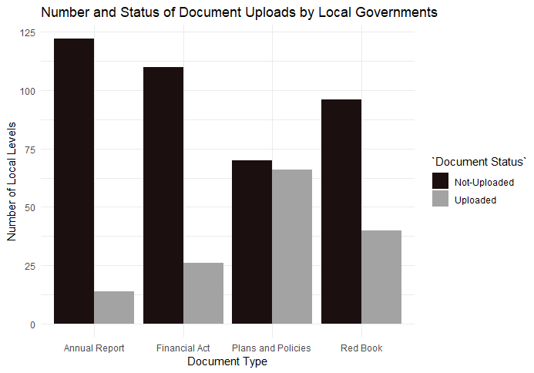

**Number of Local Levels and the document upload status**

|  |  |  |
| --- | --- | --- |
| Document | Uploaded | Not Uploaded |
| Budget- Redbook of this fiscal year | **96** | **40** |
| Budget- Plans and Policies of this fiscal year | **66** | **70** |
| Annual Report- previous year | **14** | **122** |
| Financial Act (Arthik Ain) | **26** | **110** |

Upload Quality (high): 44 (Low): 92

**Total Transparency Score in Map**

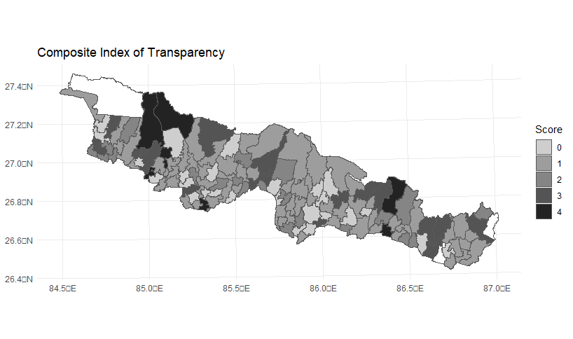

**Theme 2: Accountability**

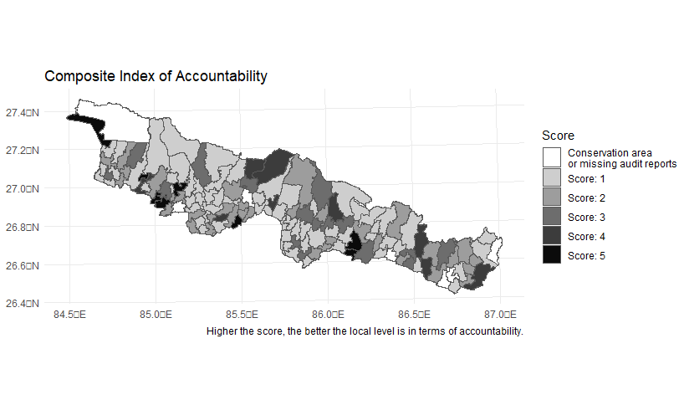

National mean of *‘beruju’* percentage is 2.82 and median is 2.135.

**Highest percentage of irregular amount (Rural Municipality)**

|  |  |
| --- | --- |
| Name of Rural Municipality | Percentage |
| Laxmipur Patari, Siraha | **25.35** |
| Naraha, Siraha | **11.20** |
| Bishnupur, Siraha | **10.30** |
| Changranagar, Sarlahi | **10.30** |
| Balan Bihul, Saptari | **9.75** |

**Highest percentage of irregular amount (among Municipality, metro, sub-metro)**

|  |  |
| --- | --- |
| Name of Rural Municipality | Percentage |
| Katahariya municipality, Rautahat | **12.92** |
| Lahan municipality, Siraha | **12.76** |
| Gadhimai municipality, Rautahat | **12.63** |
| Balwa municipality, Mahottari | **11.85** |
| Brindaban municipality, Rautahat | **11.84** |

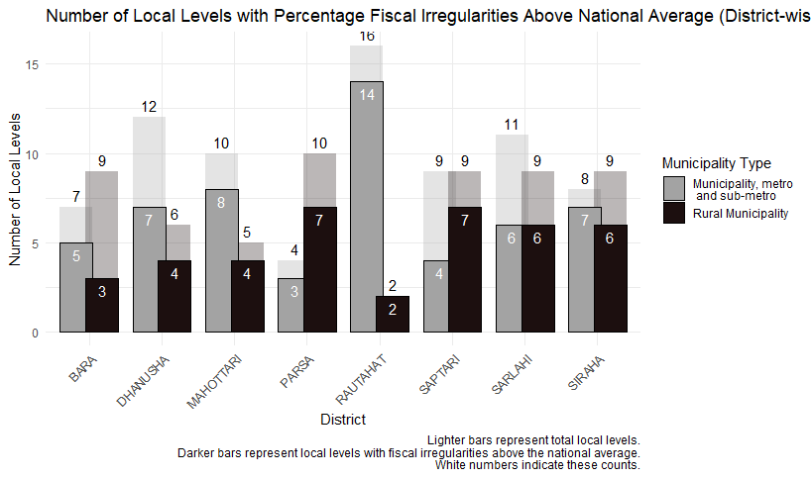

**Theme 3: Resource Use**

**Utilization of available funds**

Quantile of (1 – unused/total-available). National quantile and take the score of only Madhesh.

1 is the lowest possible score. 5 is the highest possible score

**Top five rural municipalities with the highest percentage of unused funds out of total available**

|  |  |
| --- | --- |
| Name of Rural-municipality, District | Percentage |
| Samsi, Mahottari | **42.93** |
| Mukhiyapatti Musarmiya, Dhanusha | **42.70** |
| Chandranagar, Sarlahi | **38.99** |
| Prasauni, Bara | **36.42** |
| Sonama, Mahottari | **34.47** |

**Among municipalities/metro/sub-metro, Top five units with the highest percentage of unused funds out of total available**

|  |  |
| --- | --- |
| Name of Unit, Type, District | Percentage |
| Gadhimai Municipality, Rautahat | **0** |
| Rajpur Municipality, Rautahat | **2.64** |
| Balara Municipality, Rautahat | **4.23** |
| Mirchaiya Municipality, Rautahat | **4.57** |
| Bagmati Municipality, Sarlahi | **4.67** |

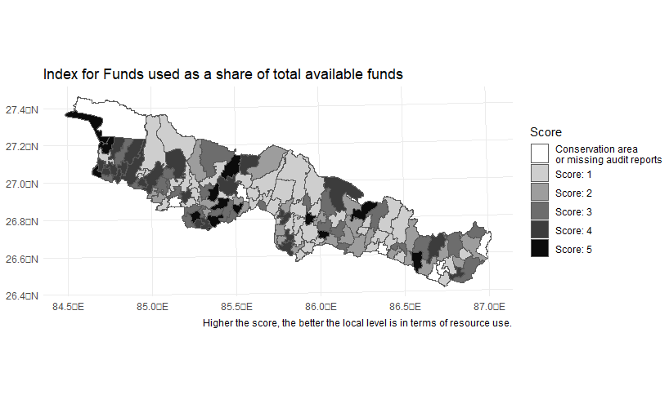**Internal Revenue Generation**

Internal revenue as share of total income

**Top five lowest rural municipalities in internal revenue generation**

|  |  |
| --- | --- |
| Name of Rural-municipality, District | Percentage |
| Durga Bhagwati, Rautahat | **0** |
| Mahadeva, Saptari | **0.19%** |
| Janakanandi, Dhanusha | **0.21%** |
| Basbariya, Sarlahi | **0.22%** |
| Jagarnathpur, Parsa | **0.23%** |

**Top five lowest municipality/metro/sub-metro in internal revenue generation**

|  |  |
| --- | --- |
| Name of metro/sub-metro/municipality, District | Percentage |
| Phatuwa Bijayapur Municipality, Rautahat | **0** |
| Katahariya Municipality, Rautahat | **0.22%** |
| Balara Municipality, Sarlahi | **0.23%** |
| Mithila Bihari Municipality, Dhanusha | **0.36%** |
| Godaita Municipality, Sarlahi | **0.39%** |

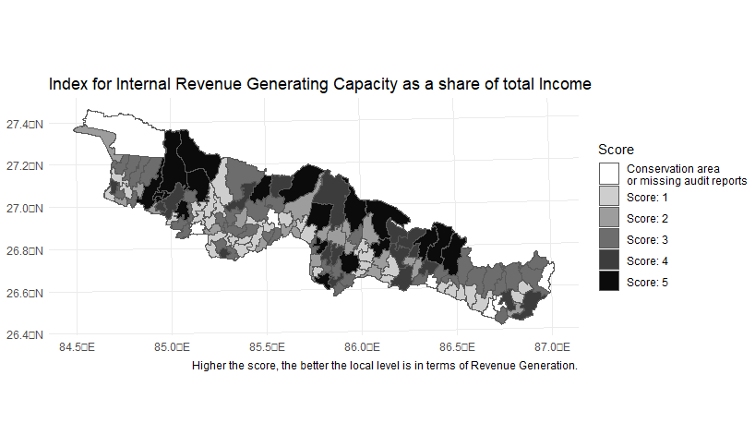

**Capital Expenditure**

**Rural municipalities with the lowest share of capital expenditure as a share of total expenditure**

|  |  |
| --- | --- |
| Name of Rural-municipality, District | Percentage |
| Rupani, Saptari | **14.83%** |
| Sonama, Mahottari | **16.55%** |
| Mahadeva, Saptari | **17.59%** |
| Aaurahi, Dhanusha | **18.18%** |
| Lakshminiya, Dhanusha | **18.50%** |

**Municipalities/metro/sub-metro with the lowest share of capital expenditure as a share of total expenditure**

|  |  |
| --- | --- |
| Name of metro/sub-metro/municipality, District | Percentage |
| Haripurwa Municipality, Sarlahi | **8.12%** |
| Hariwan Municipality, Sarlahi | **10.64%** |
| Kanchanrup Municipality, Saptari | **11.48%** |
| Sabaila Municipality, Dhanusha | **13.32%** |
| Hanumannagar Kankalini Municipality, Saptari | **13.61%** |

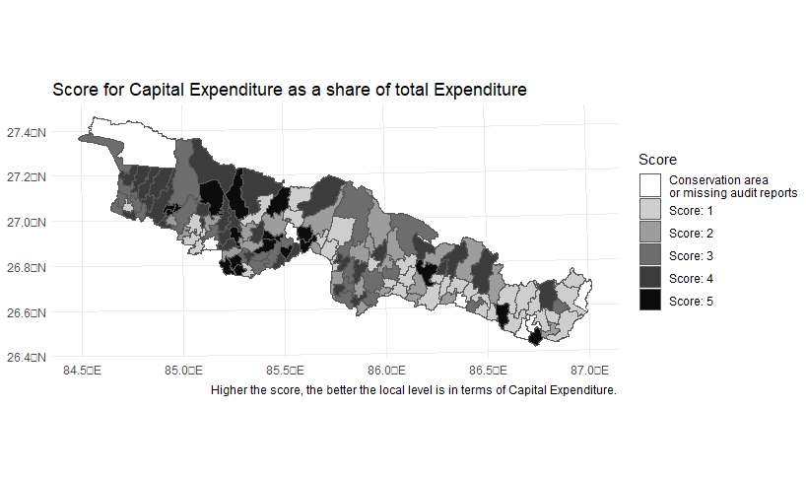

**Theme 4: Public Service Delivery**

Only based on one variable. (Status of Nagarik wadapatra uploaded)

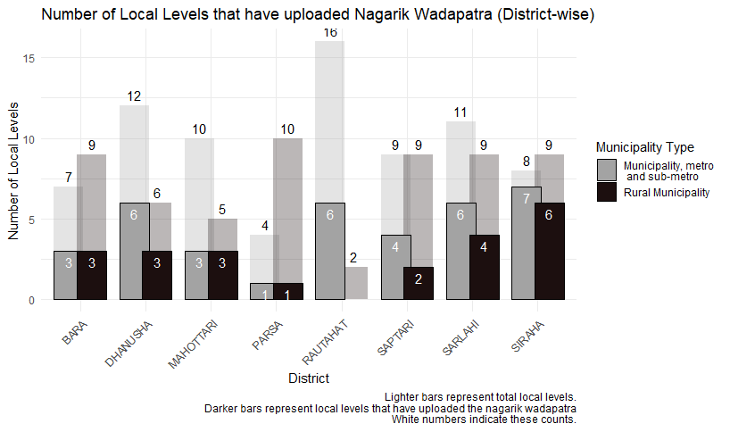

**Theme 5: Complaints (CIAA)**

**Annex**

|  |  |  |  |  |  |  |  |  |
| --- | --- | --- | --- | --- | --- | --- | --- | --- |
|  |  | **Scores for** | | | | | | |
| **UNIT_TYPE** | **UNIT_NAME** | **Transparency** | **Public Service Delivery** | **Resource Used** | | | **Public Satisfaction** | **Accountability** |
| **Capital Expenditure** | **Fund use** | **RevenueCapacity** |
| Gaunpalika | Agnisair Krishna Savaran | 1 | 0 | 4 | 3 | 3 | 0 | 2 |
| Gaunpalika | Balan Bihul | 2 | 0 | 1 | 2 | 1 | 0 | 1 |
| Gaunpalika | Belhi Chapena | 1 | 0 | 0 | 0 | 0 | 0 | 0 |
| Gaunpalika | Bishnupur | 0 | 0 | 0 | 0 | 0 | 0 | 0 |
| Nagarpalika | Bode Barsain | 0 | 1 | 5 | 5 | 1 | 0 | 4 |
| Gaunpalika | Chhinnamasta | 1 | 0 | 5 | 1 | 3 | 0 | 1 |
| Nagarpalika | Dakneshwori | 3 | 0 | 1 | 2 | 1 | 0 | 2 |
| Nagarpalika | Hanumannagar Kankalini | 1 | 0 | 1 | 3 | 4 | 0 | 4 |
| Nagarpalika | Kanchanrup | 3 | 0 | 1 | 2 | 3 | 0 | 1 |
| Nagarpalika | Khadak | 3 | 0 | 1 | 3 | 3 | 0 | 2 |
| Gaunpalika | Mahadeva | 1 | 0 | 1 | 2 | 1 | 0 | 2 |
| Nagarpalika | Rajbiraj | 1 | 2 | 1 | 1 | 4 | 0 | 1 |
| Gaunpalika | Rupani | 1 | 2 | 1 | 2 | 3 | 0 | 2 |
| Nagarpalika | Saptakoshi | 2 | 0 | 1 | 3 | 3 | 0 | 1 |
| Nagarpalika | Shambhunath | 3 | 1 | 1 | 4 | 3 | 0 | 3 |
| Nagarpalika | Surunga | 1 | 2 | 2 | 2 | 3 | 0 | 4 |
| Gaunpalika | Tilathi Koiladi | 1 | 2 | 2 | 4 | 2 | 0 | 2 |
| Gaunpalika | Tirahut | 1 | 0 | 3 | 1 | 1 | 0 | 2 |
| Gaunpalika | Arnama | 1 | 0 | 1 | 2 | 2 | 0 | 2 |
| Gaunpalika | Aurahi | 1 | 0 | 2 | 1 | 3 | 0 | 1 |
| Gaunpalika | Bariyarpatti | 4 | 2 | 0 | 0 | 0 | 0 | 0 |
| Gaunpalika | Bhagawanpur | 2 | 0 | 1 | 1 | 1 | 0 | 3 |
| Gaunpalika | Bishnupur | 0 | 2 | 1 | 1 | 2 | 0 | 1 |
| Nagarpalika | Dhangadhimai | 4 | 2 | 2 | 1 | 5 | 0 | 2 |
| Nagarpalika | Golbazar | 3 | 1 | 4 | 3 | 5 | 0 | 1 |
| Nagarpalika | Kalyanpur | 1 | 2 | 5 | 2 | 4 | 0 | 2 |
| Nagarpalika | Karjanha | 1 | 0 | 4 | 2 | 4 | 0 | 1 |
| Nagarpalika | Lahan | 2 | 2 | 4 | 1 | 5 | 0 | 1 |
| Gaunpalika | Laxmipur Patari | 1 | 2 | 1 | 1 | 3 | 0 | 1 |
| Nagarpalika | Mirchaiya | 3 | 1 | 2 | 5 | 4 | 0 | 1 |
| Gaunpalika | Naraha | 1 | 2 | 4 | 1 | 4 | 0 | 1 |
| Gaunpalika | Nawarajpur | 1 | 2 | 3 | 2 | 1 | 0 | 2 |
| Gaunpalika | Sakhuwanankarkatti | 1 | 2 | 1 | 3 | 3 | 0 | 3 |
| Nagarpalika | Siraha | 1 | 1 | 1 | 2 | 4 | 0 | 3 |
| Nagarpalika | Sukhipur | 2 | 1 | 1 | 1 | 4 | 0 | 1 |
| Gaunpalika | Aaurahi | 0 | 2 | 1 | 5 | 1 | 0 | 2 |
| Gaunpalika | Bateshwor | 1 | 1 | 2 | 3 | 2 | 0 | 1 |
| Nagarpalika | Bideha | 1 | 0 | 1 | 2 | 2 | 0 | 1 |
| Nagarpalika | Chhireshwornath | 0 | 0 | 4 | 1 | 3 | 0 | 2 |
| Gaunpalika | Dhanauji | 3 | 0 | 2 | 1 | 1 | 0 | 2 |
| Nagarpalika | Dhanusadham | 0 | 0 | 2 | 3 | 2 | 0 | 4 |
| Nagarpalika | Ganeshman Charnath | 1 | 1 | 3 | 4 | 5 | 0 | 1 |
| Nagarpalika | Hansapur | 1 | 0 | 3 | 3 | 1 | 0 | 1 |
| Gaunpalika | Janaknandani | 2 | 0 | 2 | 3 | 1 | 0 | 5 |
| Upamahanagarpalika | Janakpur | 0 | 2 | 3 | 1 | 5 | 0 | 1 |
| Nagarpalika | Kamala | 0 | 2 | 2 | 2 | 1 | 0 | 5 |
| Gaunpalika | Lakshminiya | 1 | 1 | 1 | 5 | 2 | 0 | 3 |
| Nagarpalika | Mithila | 1 | 2 | 2 | 1 | 5 | 0 | 3 |
| Nagarpalika | Mithila Bihari | 0 | 0 | 2 | 2 | 1 | 0 | 3 |
| Gaunpalika | Mukhiyapatti Musarmiya | 1 | 0 | 2 | 1 | 3 | 0 | 1 |
| Nagarpalika | Nagarain | 0 | 1 | 3 | 1 | 3 | 0 | 2 |
| Nagarpalika | Sabaila | 3 | 0 | 1 | 1 | 5 | 0 | 3 |
| Nagarpalika | Sahidnagar | 1 | 1 | 1 | 3 | 2 | 0 | 1 |
| Nagarpalika | Aurahi | 1 | 0 | 3 | 2 | 2 | 0 | 2 |
| Nagarpalika | Balwa | 1 | 0 | 3 | 1 | 4 | 0 | 1 |
| Nagarpalika | Bardibas | 1 | 2 | 3 | 1 | 4 | 0 | 2 |
| Nagarpalika | Bhangaha | 1 | 0 | 2 | 1 | 2 | 0 | 3 |
| Gaunpalika | Ekdanra | 1 | 1 | 4 | 2 | 1 | 0 | 1 |
| Nagarpalika | Gaushala | 2 | 2 | 1 | 1 | 5 | 0 | 1 |
| Nagarpalika | Jaleswor | 2 | 1 | 3 | 4 | 5 | 0 | 1 |
| Nagarpalika | Loharpatti | 1 | 0 | 4 | 1 | 4 | 0 | 1 |
| Gaunpalika | Mahottari | 1 | 0 | 3 | 4 | 3 | 0 | 3 |
| Nagarpalika | Manra Siswa | 1 | 0 | 2 | 2 | 2 | 0 | 1 |
| Nagarpalika | Matihani | 0 | 0 | 4 | 2 | 4 | 0 | 3 |
| Gaunpalika | Pipra | 2 | 2 | 2 | 1 | 3 | 0 | 1 |
| Nagarpalika | Ramgopalpur | 2 | 0 | 4 | 4 | 5 | 0 | 1 |
| Gaunpalika | Samsi | 0 | 2 | 1 | 1 | 3 | 0 | 1 |
| Gaunpalika | Sonama | 0 | 0 | 1 | 1 | 1 | 0 | 1 |
| Nagarpalika | Bagmati | 0 | 0 | 5 | 5 | 5 | 0 | 1 |
| Nagarpalika | Balara | 1 | 2 | 3 | 5 | 1 | 0 | 1 |
| Nagarpalika | Barahathawa | 1 | 1 | 2 | 4 | 3 | 0 | 2 |
| Gaunpalika | Basbariya | 1 | 2 | 5 | 1 | 1 | 0 | 1 |
| Gaunpalika | Bishnu | 0 | 0 | 4 | 3 | 2 | 0 | 5 |
| Gaunpalika | Bramhapuri | 3 | 2 | 5 | 1 | 2 | 0 | 1 |
| Gaunpalika | Chakraghatta | 2 | 1 | 3 | 2 | 1 | 0 | 2 |
| Gaunpalika | Chandranagar | 1 | 0 | 5 | 1 | 1 | 0 | 1 |
| Gaunpalika | Dhankaul | 2 | 0 | 5 | 5 | 3 | 0 | 2 |
| Nagarpalika | Godaita | 1 | 0 | 3 | 3 | 1 | 0 | 2 |
| Nagarpalika | Haripur | 2 | 1 | 1 | 1 | 3 | 0 | 3 |
| Nagarpalika | Haripurwa | 3 | 1 | 1 | 1 | 1 | 0 | 4 |
| Nagarpalika | Hariwan | 1 | 1 | 1 | 4 | 4 | 0 | 4 |
| Nagarpalika | Ishworpur | 3 | 2 | 2 | 1 | 2 | 0 | 1 |
| Nagarpalika | Kabilasi | 1 | 0 | 0 | 0 | 0 | 0 | 0 |
| Gaunpalika | Kaudena | 1 | 0 | 5 | 5 | 3 | 0 | 2 |
| Nagarpalika | Lalbandi | 1 | 0 | 4 | 2 | 5 | 0 | 4 |
| Nagarpalika | Malangawa | 2 | 0 | 4 | 2 | 3 | 0 | 2 |
| Gaunpalika | Parsa | 2 | 2 | 2 | 3 | 2 | 0 | 1 |
| Gaunpalika | Ramnagar | 0 | 0 | 3 | 3 | 1 | 0 | 4 |
| Nagarpalika | Baudhimai | 0 | 0 | 4 | 1 | 2 | 0 | 1 |
| Nagarpalika | Brindaban | 1 | 0 | 1 | 1 | 4 | 0 | 1 |
| Nagarpalika | Chandrapur | 3 | 2 | 4 | 3 | 3 | 0 | 1 |
| Nagarpalika | Dewahhi Gonahi | 2 | 0 | 5 | 1 | 3 | 0 | 1 |
| Gaunpalika | Durga Bhagwati | 0 | 0 | 4 | 2 | 1 | 0 | 2 |
| Nagarpalika | Gadhimai | 0 | 0 | 4 | 5 | 2 | 0 | 1 |
| Nagarpalika | Garuda | 1 | 0 | 2 | 3 | 3 | 0 | 1 |
| Nagarpalika | Gaur | 1 | 1 | 5 | 4 | 4 | 0 | 1 |
| Nagarpalika | Gujara | 1 | 0 | 5 | 2 | 1 | 0 | 3 |
| Nagarpalika | Ishanath | 1 | 2 | 5 | 3 | 1 | 0 | 2 |
| Nagarpalika | Katahariya | 1 | 0 | 4 | 1 | 1 | 0 | 1 |
| Nagarpalika | Madhav Narayan | 1 | 1 | 2 | 2 | 3 | 0 | 1 |
| Nagarpalika | Maulapur | 0 | 0 | 4 | 4 | 1 | 0 | 1 |
| Nagarpalika | Paroha | 3 | 1 | 2 | 3 | 1 | 0 | 2 |
| Nagarpalika | Phatuwa Bijayapur | 1 | 0 | 4 | 1 | 1 | 0 | 1 |
| Nagarpalika | Rajdevi | 4 | 0 | 1 | 4 | 3 | 0 | 2 |
| Nagarpalika | Rajpur | 0 | 1 | 5 | 5 | 3 | 0 | 1 |
| Gaunpalika | Yemunamai | 1 | 0 | 3 | 3 | 1 | 0 | 1 |
| Gaunpalika | Adarshkotwal | 1 | 2 | 3 | 3 | 1 | 0 | 2 |
| Gaunpalika | Baragadhi | 1 | 1 | 2 | 1 | 1 | 0 | 5 |
| Gaunpalika | Bishrampur | 1 | 0 | 4 | 3 | 2 | 0 | 4 |
| Gaunpalika | Devtal | 4 | 0 | 2 | 2 | 1 | 0 | 5 |
| Upamahanagarpalika | Jitpur Simara | 4 | 2 | 3 | 1 | 5 | 0 | 1 |
| Upamahanagarpalika | Kalaiya | 3 | 0 | 3 | 4 | 4 | 0 | 2 |
| Gaunpalika | Karaiyamai | 4 | 0 | 4 | 3 | 3 | 0 | 1 |
| Nagarpalika | Kolhabi | 0 | 0 | 5 | 4 | 5 | 0 | 1 |
| Nagarpalika | Mahagadhimai | 1 | 0 | 1 | 3 | 5 | 0 | 3 |
| Nagarpalika | Nijgadh | 4 | 1 | 4 | 1 | 5 | 0 | 1 |
| Nagarpalika | Pacharauta | 1 | 0 | 1 | 1 | 3 | 0 | 2 |
| Gaunpalika | Parwanipur | 3 | 2 | 5 | 1 | 5 | 0 | 5 |
| Gaunpalika | Pheta | 0 | 0 | 2 | 4 | 4 | 0 | 1 |
| Gaunpalika | Prasauni | 3 | 0 | 5 | 1 | 5 | 0 | 4 |
| Nagarpalika | Simraungadh | 1 | 2 | 0 | 0 | 0 | 0 | 0 |
| Gaunpalika | Suwarna | 0 | 0 | 1 | 2 | 3 | 0 | 5 |
| Nagarpalika | Bahudaramai | 1 | 0 | 4 | 4 | 2 | 0 | 2 |
| Gaunpalika | Bindabasini | 2 | 0 | 3 | 4 | 3 | 0 | 2 |
| Mahanagarpalika | Birgunj | 1 | 2 | 4 | 4 | 5 | 0 | 1 |
| Gaunpalika | Chhipaharmai | 2 | 2 | 3 | 5 | 1 | 0 | 1 |
| Gaunpalika | Dhobini | 3 | 0 | 3 | 4 | 4 | 0 | 1 |
| Gaunpalika | Jagarnathpur | 0 | 0 | 3 | 1 | 1 | 0 | 2 |
| Gaunpalika | Jirabhawani | 0 | 0 | 4 | 5 | 3 | 0 | 1 |
| Gaunpalika | Kalikamai | 3 | 0 | 1 | 4 | 3 | 0 | 3 |
| Gaunpalika | Pakahamainpur | 2 | 0 | 4 | 3 | 2 | 0 | 1 |
| Nagarpalika | Parsagadhi | 2 | 0 | 4 | 4 | 3 | 0 | 3 |
| Gaunpalika | Paterwasugauli | 3 | 0 | 4 | 4 | 3 | 0 | 1 |
| Nagarpalika | Pokhariya | 2 | 0 | 3 | 4 | 1 | 0 | 1 |
| Gaunpalika | SakhuwaPrasauni | 1 | 0 | 4 | 3 | 3 | 0 | 2 |
| Gaunpalika | Thori | 1 | 0 | 3 | 5 | 2 | 0 | 5 |